Use Case Diagram (Manager)

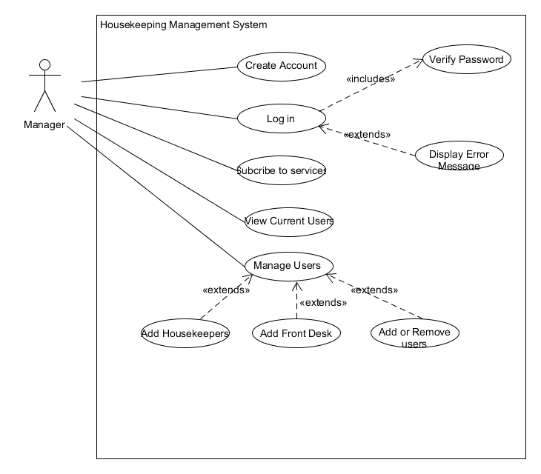

Manager interaction with the housekeeping application, the manager firstly needs to create and account and log in and subscribe to the services in order to use the application.

Activity Diagram (Manager)

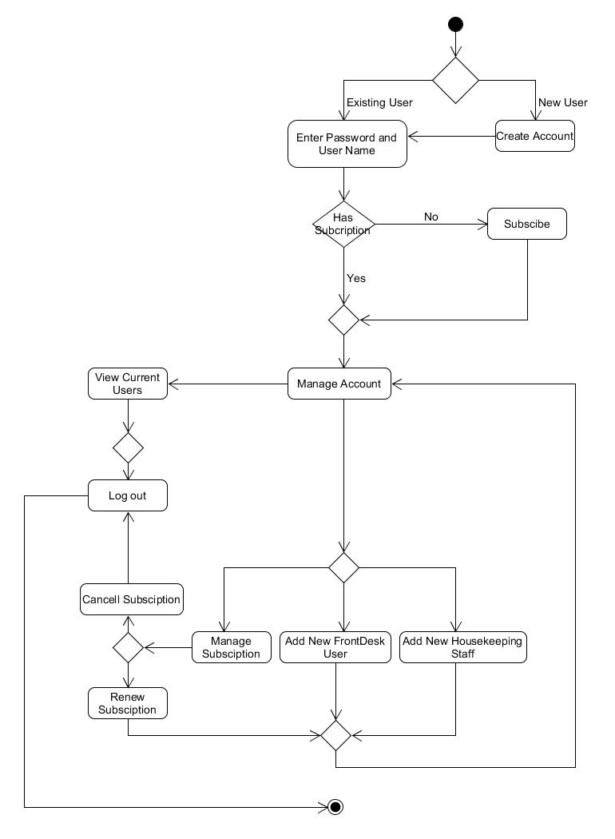

Activity Diagram steps

|  |  |
| --- | --- |
| 1 | If the manager is a new user then they need to create a account |
| 2 | IF Manager is an existing they need to first log in to the system |
| 3 | IF the manager doesn’t have subscription the manger need to subscribe to the services |
| 4 | IF the manger has a subscription then the manager can add or remove users |
| 5 | View existing users |
| 6 | Manage Subscription |
| 7 | Add new front desk staff |
| 8 | Add New Housekeeping Staff |
| 9 | Renew or cancel subscription |
| 10 | Log out |

System Function of Manager

|  |  |  |  |  |
| --- | --- | --- | --- | --- |
| Activity | Input | Process | Output | User |
| Creating Account | * User Name * Password * Email | Add Username and password, Email to database | Send Email to confirm user | User gets confirmation via email of the account |
| Subscribe to service | * Name of accommodation * Number of rooms * Enter payment option | Add to users database and reconfirm user input | Send email to confirm payment | Manager can add users (Front desk , Housekeepers) |
| Add Housekeepers | * First and last name * Contact details * Allocate ID and password | Add to database the user name and ID | Display user details and position | Housekeeper Staff can log in to the interface |
| Add Front desk | * First and last name * Contact details * Allocate ID and password | Allocate information to database with user name, ID and position | Display user Details and position | Front desk can view housekeepers and rooms in the accommodation |
| Renewal or cancellation of Service | * Login With user name and password | Select manage account and select renew or cancel service | Either cancel services with take you to main screen,  Renew will take you to main screen. | Manager will get an email confirming the changes (Renewal or Cancellation) |